 **Year 7 Angles make a difference**

Name: _________________

Class: _____________

**Weighting: 20%**

**Total marks 24**

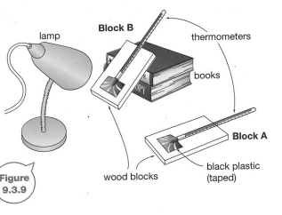

**/24**

**Variables**

Independent variable: **(1 mark)**

**___________________________________________________________________________**

Dependent variable: **(1 mark)**

**___________________________________________________________________________**

2 controlled variables:  **(2 marks)**

**___________________________________________________________________________**

**___________________________________________________________________________**

**Hypothesis: (2 marks)**

**___________________________________________________________________________**

**___________________________________________________________________________**

**Results:** Complete the table by entering the relevant heading titles and units where needed and calculate the averages to enter this data. **(2 marks)**

|  |  |  |
| --- | --- | --- |
| Time (min) |  | |
| Block B | Block A |
| 1 | 12 | 5 |
| 2 | 34 | 10 |
| 3 | 52 | 15 |
| 4 | 70 | 20 |
| 5 | 86 | 25 |

Use the **graph paper** provided to draw a graph of the results plotting time vs temperature on the appropriate axis (8 marks)



**Discussion:**

Identify which block showed the greatest increase in temperature (1 mark)

**__________________________________________________________________________**

Identify which block modelled the surface area of the Earth in: (1 mark)

1. Far north Queensland _______________
2. Southern Tasmania ________________

Use your results to explain why (6 marks)

1. the tropics are found near the equator

**__________________________________________________________________________**

**__________________________________________________________________________**

**__________________________________________________________________________**

**__________________________________________________________________________**

1. icebergs are only found near the poles

**___________________________________________________________________________**

**___________________________________________________________________________**

**___________________________________________________________________________**

**___________________________________________________________________________**